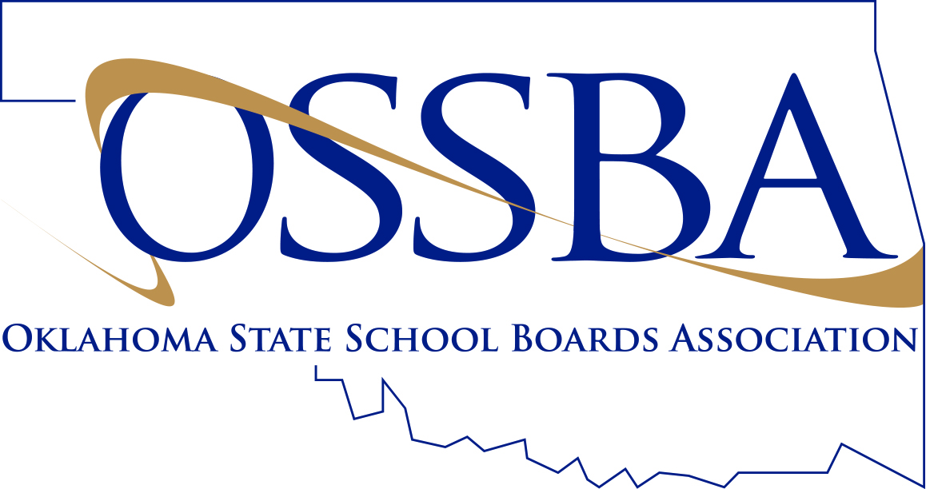

Registration Form

OSSBA Region 12 Meeting (6:30 p.m.) &
Pre-Region Meeting Workshop (5:30 p.m.) –
“School Board’s Role in Student Achievement”

Ardmore High School Commons

Tuesday – March 27, 2018
To register, fax this form to the OSSBA at (405) 528-5695 or
Mail to: OSSBA, 2801 N. Lincoln Blvd., Ste. 125, Oklahoma City, OK 73105 or
Call Mong Chia at 1-888-528-3571 or e-mail to mong@ossba.org

Even if you were previously registered for the February 22nd meeting, be sure to register for this March 27th meeting if you still plan to attend.

Deadline to register: March 19, 2018

Please Print or Type.

Name of School District: Contact Person, Phone # & E-Mail Address:

Please check the appropriate box(es) beside each name so we’ll know which meeting(s) each registrant plans to attend. Thank you!
Board Member | Pre-Reg.  Wrkshp | Reg.Mtg  w/meal |  | Board Member | Pre-Reg.  Wrkshp | Reg.Mtg  w/meal

Administrator | Pre-Reg.  Wrkshp | Reg.Mtg  w/meal |  | Administrator | Pre-Reg.  Wrkshp | Reg.Mtg  w/meal

* Only School Board Members and two (2) administrators from each member school will be guests of the OSSBA.
Additional guest(s): $25 per guest = _________ x $25 = $____________

P.O. number and name for additional member guest(s):

** Registration fee for non-member districts: $60 per person = _________ x $60 = $____________

*** Payment is expected for additional guests and non-members prior to the event.

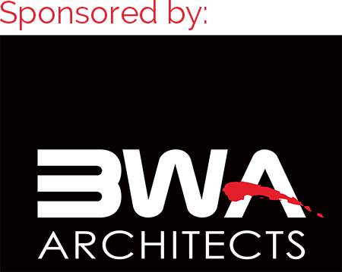
School board members attending this meeting will receive the following credit hours:
1 Ethics & 1 New Laws &
1 Continuing Education (if you attend the Pre-Region Meeting Workshop)

