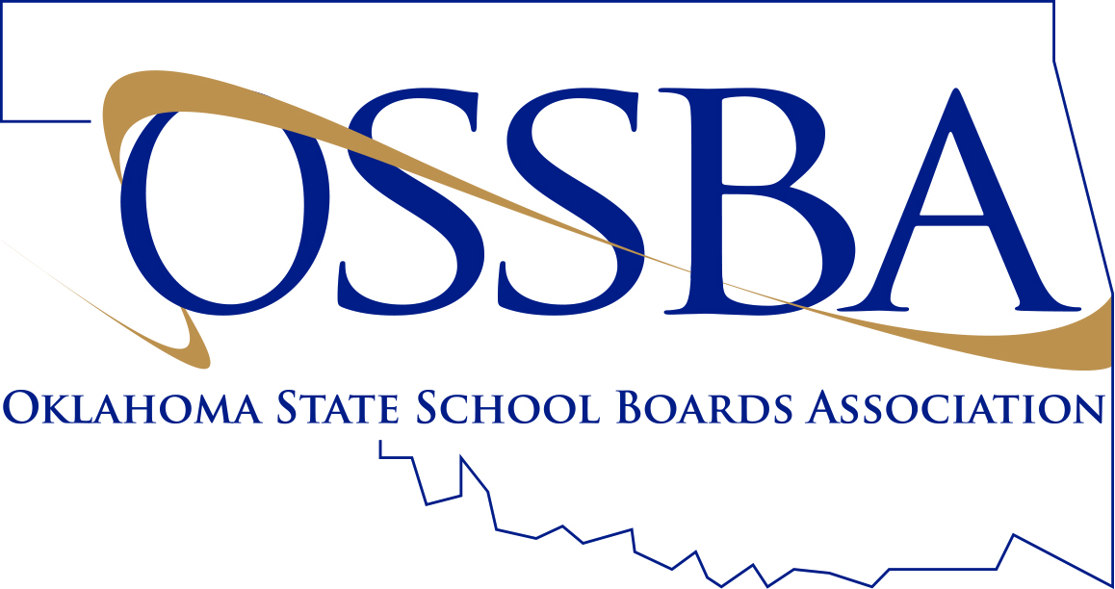
Registration Form

OSSBA Region 6 Meeting (6:30 p.m.) &
Pre-Region Meeting Workshop (5:30 p.m.) –
“Board’s Role in Student Achievement”
OSSBA Conference Center (2nd Level)
OSSBA Building

Oklahoma City, Oklahoma

Tuesday – March 27, 2018
Even if you were previously registered for the February 20th meeting, please be sure to register for the March 27th meeting if you still plan to attend.

To register, fax this form to the OSSBA at (405) 528-5695 or
Mail to: OSSBA, 2801 N. Lincoln Blvd., Ste. 125, Oklahoma City, OK 73105 or
Call Mong Chia at 1-888-528-3571 or e-mail to mong@ossba.org

Deadline to register: March 19, 2018
Please Print or Type.

Name of School District: Contact Person, Phone # & E-Mail Address:

Please check the appropriate box(es) beside each name so we’ll know which meeting(s) each registrant plans to attend. Thank you!
Board Member | Pre-Reg.  Wrkshp | Reg.Mtg  w/meal |  | Board Member | Pre-Reg.  Wrkshp | Reg.Mtg  w/meal

Administrator | Pre-Reg.  Wrkshp | Reg.Mtg  w/meal |  | Administrator | Pre-Reg.  Wrkshp | Reg.Mtg  w/meal

* Only School Board Members and two (2) administrators from each member school will be guests of the OSSBA.
Additional guest(s): $25 per guest = _________ x $25 = $____________

P.O. number and name for additional member guest(s):

** Registration fee for non-member districts: $60 per person = _________ x $60 = $____________

*** Payment is expected for additional guests and non-members prior to the event.
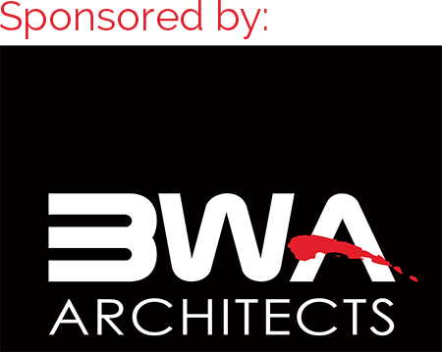
School board members attending this meeting will receive the following credit hours:
1 Ethics & 1 New Laws &
1 Continuing Education (if you attend the Pre-Region Meeting Workshop)

