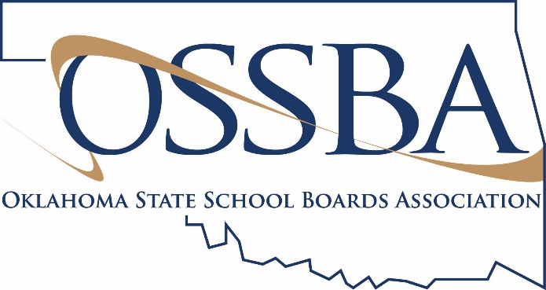
Template Letter for School Family
Topic: Long-term School Closure Recommended, Learning to Continue
If you need assistance finalizing this letter, please contact Amber Graham Fitzgerald, Director of Member Engagement, at amberf@ossba.org or 405.528.3571.
[Date]
Dear [District] family:
Today, state officials announced they will recommend to the state Board of Education that Oklahoma students not return to the classroom for the remainder of the current school year, as our state continues to fight the spread of COVID-19. They will instead recommend a continuous learning plan that will allow students to complete the school year at home. It is important to note that this decision is not final until the state Board of Education meets on Wednesday and votes to approve the recommendation.
We are sharing this information with you in advance, however, so that you can begin to prepare accordingly for your family. We understand this recommendation is in the best interest of everyone’s health, which is our greatest priority as a district. If approved, this also means that all extracurricular activities and special events will be canceled as well. Making these difficult decisions, we believe, is simply the right thing to do for our students, our staff and our community.
We do have good news: [District] is developing a plan to ensure your child will continue to have opportunities to learn and to grow academically, especially with parental support. Because we are unable to safely gather together, these lessons and activities will primarily be delivered and communicated [insert delivery method]. As you can imagine, this is a significant transition for our students and our teachers. [District] will spend the next two weeks planning for this effort and will share details with your family as soon as they are available. Teachers and support staff members will hear from their principals soon as they gather input regarding the next phase of the school closure.
For students, it likely will be sad and disappointing to learn that school as they know it will not resume this year. Please give them a safe place to express their feelings and to vent about the changes in their life. For our seniors and their parents, we know it is an especially difficult time. We will do everything possible to ensure their efforts are recognized and celebrated in special and unique ways. This is an unfair situation, but please reassure them that it does not diminish their achievements. In fact, it will become one more example of how they demonstrated their strength as [Mascot].
We have posted numerous resources on our website, including information about free breakfasts and lunches for students under the age of 18, which will continue, as well as answers to frequently asked questions regarding the school closure. You can find these details and more by visiting [website]. The site also includes recommendations from the CDC about protecting your health and the health of your loved ones. We ask you to please follow their advice by: (1) washing your hands regularly; (2) staying at home, if you can; and (3) practicing social distancing of at least six feet from others.
This is an unprecedented situation, and it has required an unprecedented response. We can still take care of [Town Name]’s students, though. This is a community that sticks together in challenging times, and we know this experience will be no different. As soon as we identify our next steps, we will share them with you.
Please stay safe. As always, we appreciate your support of [District].
Sincerely,
[Name]
Superintendent

