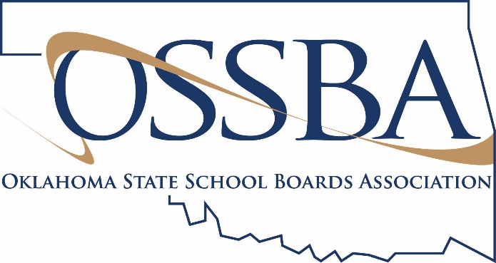
Template Phone Script for School Family
Topic: Long-term School Closure Recommended, Learning to Continue
If you need assistance finalizing this script, please contact Amber Graham Fitzgerald, Director of Member Engagement, at amberf@ossba.org or 405.528.3571.
Good afternoon. This is Superintendent [Name] and this message is for the [District] family. Today, the state Board of Education did accept State Superintendent Joy Hofmeister’s recommendation to close Oklahoma school buildings through the end of the year. Please know, however, that learning will continue.
[District] is developing a plan to ensure all students have the opportunity to continue to grow academically, safely at home with parental support. Lessons and activities will be provided to students through [insert delivery method.] Our plan will be flexible so that it will work for all students, and we will share the details with you as soon as they are available.
I know this is an unprecedented situation, and people have worries and questions about this change. I understand your concerns, but I know, as a community and as a district, we can find solutions to this problem. We must for our students.
I especially want to say a word to the Class of 2020. This is disappointing, it’s frustration and it is not fair. Please don’t let it diminish your accomplishments and your excitement about graduation … because we won’t. It is our sincere hope that we can give you the ceremony and celebration you deserve as soon as our state’s medication professionals determine it safe to do so. We won’t forget you. We promise.
Until then, though, we need everyone to do what the CDC has recommended to protect your health: wash your hands; stay at home, if you can; and practice social distancing. Even in this challenging time, we will continue to learn and grow together … even while we have to be apart.
As always, you can learn more by visiting our website at [website]. Thank you for your support of [District].

