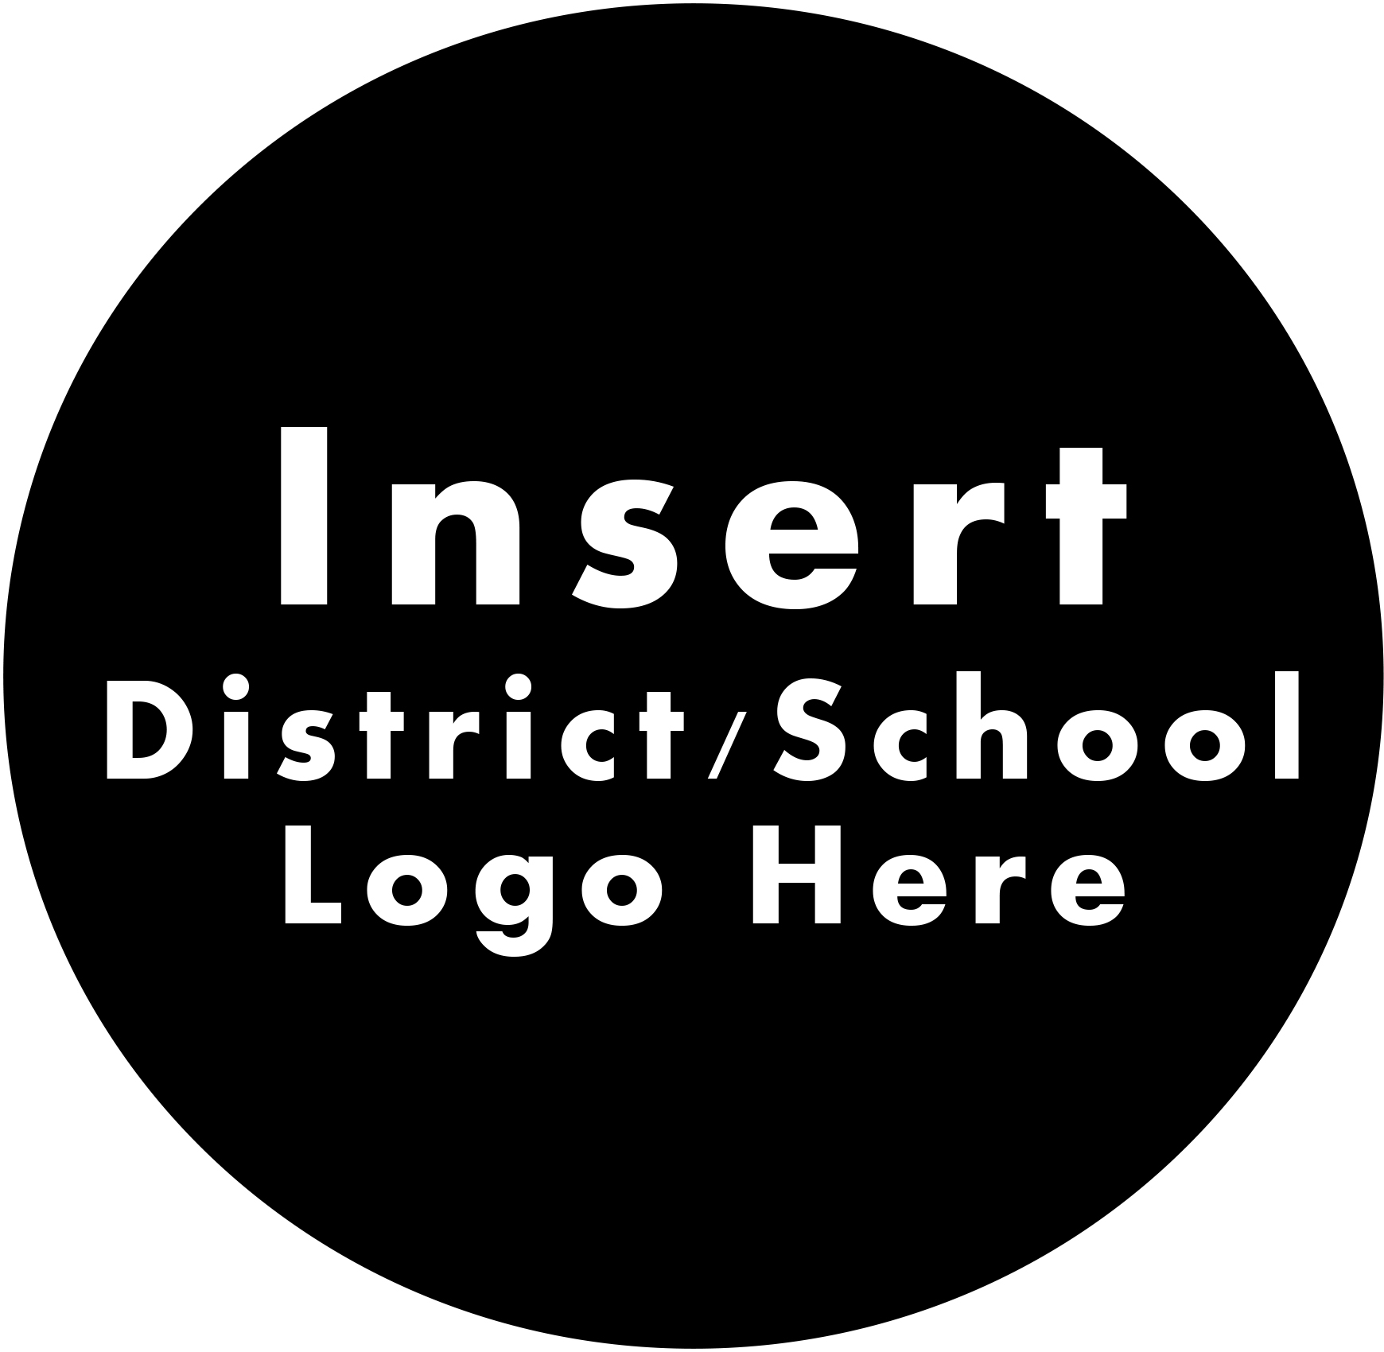
CONSENT FORM TO OPT-OUT FACE MASK REQUIREMENT
If an employee indicates that compliance with mask use is not possible due to a medical condition or religious beliefs, they may request an exemption in writing.

**SIGNED FORM MUST BE ON FILE AT THE DISTRICT OFFICE **

Employee Information
First and Last Name:
School: | Position:

Exemption Type
Medical: I hereby certify I have a medical condition(s) that prevents compliance with the mask requirement.
Religious: I hereby certify the mask requirement conflicts with my religious beliefs.

Printed Name of Employee Signature of Employee

Date

